Ideation Phase
Sprint Planning Logic — Epics, Stories, Story Points & Velocity
Date | 7 July 2026
Team ID | SWTID-2026-2247
Project Name | Emotion Detection and Learning Support Engine

What is a Sprint?
A sprint is a fixed period of time — typically one to four weeks — during which a team commits to completing a defined set of tasks. For the Emotion Detection and Learning Support Engine, each sprint is planned as a 6-day cycle, giving the team a short, focused window to deliver a working increment of the product.
What is an Epic?
An epic is a large body of work — too big to finish in a single sprint — that is broken down into smaller, deliverable stories spread across multiple sprints. In this project, the six epics (Environment Setup, Kaggle Model Training, Core Emotion Detection Pipeline, AI Guidance Engine, Streamlit UI, and User Interaction/Testing) each represent one major area of the system.
What is a Story?
A story is a small, independently completable unit of work that belongs to an epic. Each story is written from the user's or developer's point of view (“As a ___, I can ___ so that ___”) and is estimated in story points before being assigned to a sprint.
What is a Story Point?
A story point is a relative measure of the effort a story takes to complete, usually expressed using the Fibonacci sequence (1, 2, 3, 5, 8...). Smaller numbers represent simpler, low-effort stories; larger numbers represent stories with more complexity, risk, or unknowns.
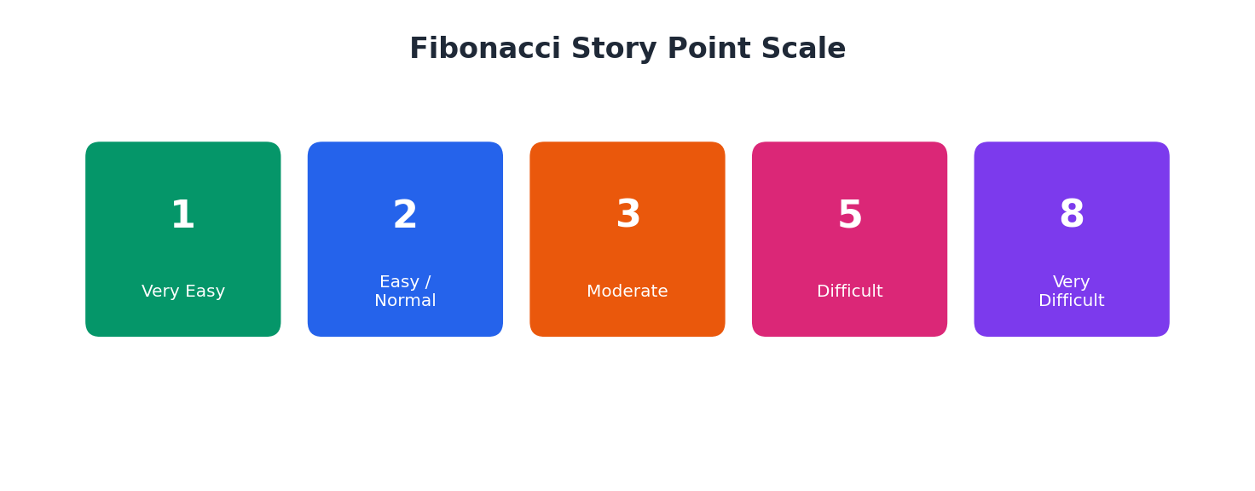
Worked Example: Emotion Detection and Learning Support Engine
The backlog for this project is organized into 5 sprints across the 6 epics. Each user story below carries a Fibonacci story point estimate.
Sprint-1 — Environment Setup
USN1 Obtain Gemini API Key — 1 pt
USN2 Install Python & Create Virtual Environment — 1 pt
USN3 Install Project Dependencies — 2 pt
USN4 Create the .env Configuration File — 1 pt
USN5 Verify Model and Data Directories — 1 pt
USN6 Prepare Project Folder Structure — 2 pt
Total Story Points in Sprint-1 = 1+1+2+1+1+2 = 8
Sprint-2 — Kaggle Model Training
USN7 Kaggle Setup (GPU + Dependencies + Data Loading) — 3 pt
USN8 Data Preprocessing & Tokenization — 3 pt
USN9 BiLSTM Model Training — 5 pt
USN10 Domain-Adaptive Fine-Tuning — 5 pt
USN11 BERT Model Fine-Tuning — 5 pt
USN12 Model Export & Local Integration — 3 pt
Total Story Points in Sprint-2 = 3+3+5+5+5+3 = 24
Sprint-3 — Core Emotion Detection Pipeline
USN13 Text Preprocessing & Keyword Enhancement — 2 pt
USN14 BiLSTM Classifier (5-Class Softmax) — 3 pt
USN15 BERT Classifier with Class Weighting — 3 pt
USN16 Mixed Emotion Detection (≥15% Secondary) — 3 pt
USN17 Unified Prediction Schema — 2 pt
USN18 CSV Persistence & Cached Model Loading — 2 pt
Total Story Points in Sprint-3 = 2+3+3+3+2+2 = 15
Sprint-4 — AI Guidance Engine & UI Foundation
USN19 Capture Field and Problem Context — 2 pt
USN20 Generate Empathetic AI Responses — 3 pt
USN21 Response Regeneration & Synchronization — 3 pt
USN22 Session History & CSV Logging — 2 pt
USN23 Responsive Layout & Session State — 2 pt
Total Story Points in Sprint-4 = 2+3+3+2+2 = 12
Sprint-5 — UI Completion & Testing
USN24 Emotion Analysis & Model Comparison Visualization — 3 pt
USN25 Form Controls, Validation & Error Handling — 2 pt
USN26 Analytics Dashboard & Interactive Charts — 3 pt
USN27 Validate UI Flow End-to-End — 2 pt
USN28 Optimization & Deployment Readiness — 3 pt
Total Story Points in Sprint-5 = 3+2+3+2+3 = 13
Total Story Points
Sprint-1 = 8
Sprint-2 = 24
Sprint-3 = 15
Sprint-4 = 12
Sprint-5 = 13
Velocity = Total Story Points Completed / Number of Sprints
Total Story Points = 8 + 24 + 15 + 12 + 13 = 72
Number of Sprints = 5
Velocity = 72 / 5 = 14.4 (Story Points per Sprint)
The team's velocity for the Emotion Detection and Learning Support Engine is 14.4 story points per sprint.
